## UML Diagram of classes:

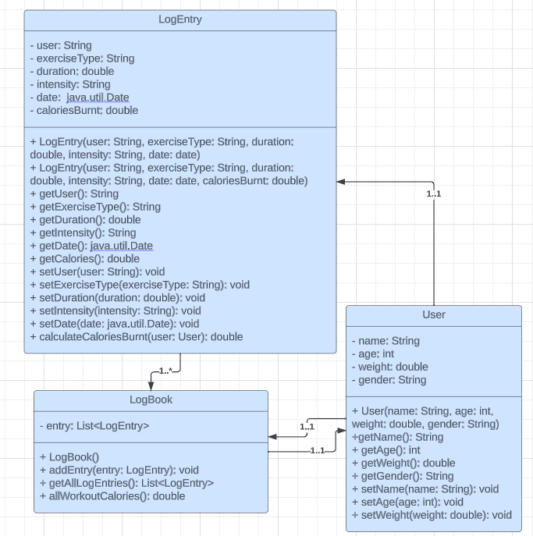

**Full User input (If unable to see images, image quality should be enough to zoom in without problems)**

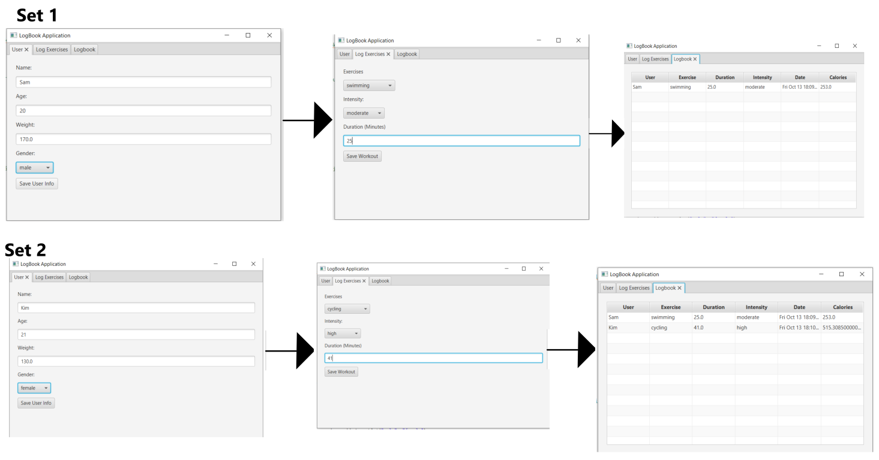

**The program starts off with a user tab where the user will input information about themselves like name, age and weight. The textfields will automatically adjust to the datatype they’re supposed to be, or they will be deleted if the input is unable to be made into the correct one.**

**After pressing save, the user can go onto the workout tab and select a variety of exercises, the intensity, then input the duration. After it saves, the user can go to the logbook tab and see the workout logged.**

**This can be done with different users as well, and the calculations will be different based on gender and weight.**

**Missing inputs**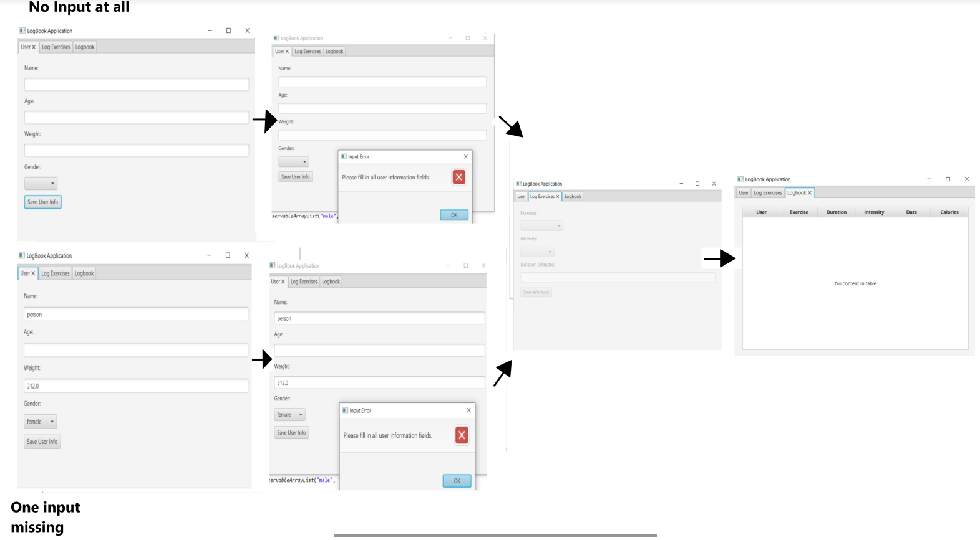

**If the user doesn’t input anything in the user tab or misses one field and tries to save, they will be met with an error message that says they need to fill out the fields.**

**If the user is new and there’s no entries, then the workout tab will be disabled for them until they input information for the user tab. The table will also be blank.**